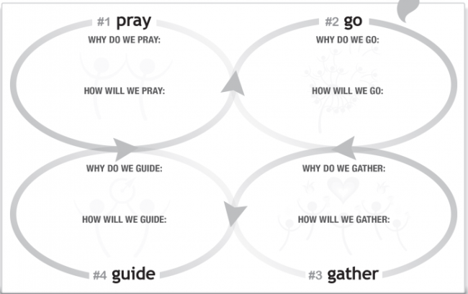
Rapid Multiplication Requires Simplicity and Purity
Elephants vs Rabbits – After 2 years, 2 elephants become 3 while 2 rabbits become 1,369!
Meeting Goals requires Clarity and Intentionality
Jesus Movement was slowed down by high bar of theological requirement. Time for a REBOOT
Simple Start – 2 Cor 11:3; Love God
How do you love the Lord? Do more for Him? He’s got angels for that who don’t complain. We need to learn how to relate to Him (like young Samuel, “Lord, your servant [minister] is listening” and enter his gates with thanksgiving in your heart)
What if, when you woke up this morning, God was excited that you were awake and wanted to interact with you?
Simple Message – 1 Cor 2:2; Romans 15:18
“EVERYONE PLAYS”
Simple Strategy - Luke 10:1-2 – Gather in pairs and pray Luke 10:2 at 10:02 on the clock, then each person finds another to pair up with.
- Identifying a field
  - Work: “where do you spend the most time that is not your own?”
  - Play: “where do you spend the most time doing what you like?”
  - Live: “where do you lay your head and who lives in and near your house?”
- Pray – “Lord, send laborers into your harvest (in this group)”
- Seek – “who in that group can you pray this prayer with?”
- Multiply – “Can you each find one more person?”

Simple Discipleship Chain - DiscipleX


Simple Bible Study – read any passage and look ask yourself these 4 questions:
- What’s something in the passage you didn't understand?
- What’s something that triggered a thought or idea?
- What’s something that strikes your heart (in light of this, I need to do something differently)?
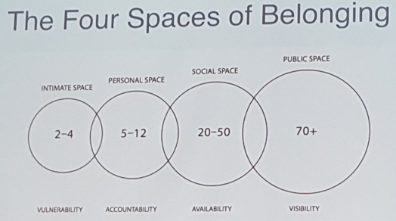
- What have I heard today that someone else I know needs to hear?
Simple Movement –

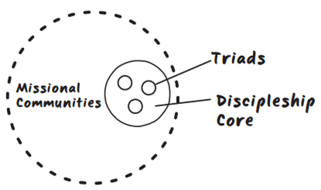

Simply Release –
- Jesus Released:
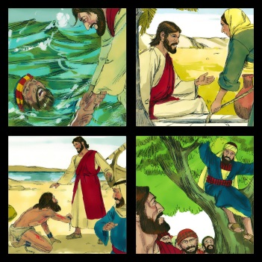
  - Jesus sent the 72 without 4 years of seminary to do big, scary things
  - Jesus said “no” to the demoniac who wanted to come with Him
  - He sent the Holy Spirit to guide each of us
- Process of Release
  - Model – As you enter a new Oikos (campus, sports team, town, office, etc) and look for a person of peace, be incarnational, living with them and showing a new way of life
  - Assist – As some of them mature and begin to go out, be present and do life together
  - Watch – As you back up to let it grow, be available to help them think things through before and after
  - Leave – As they begin to draw in new people, be invisible so they have the freedom to lead and you can begin to reach a new Oikos

